\*The following screenshots were taken from the initial testing batch of beta testers. Apologies for any foul language, for legal reasons I myself do not condone any of the behaviors of these testers.\*

Character Creation

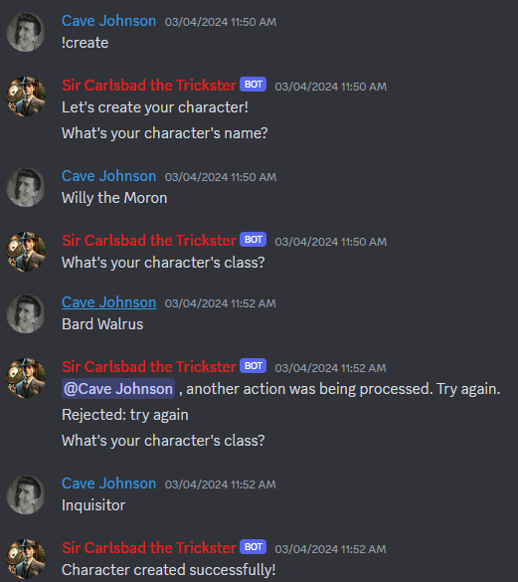

Stats Page

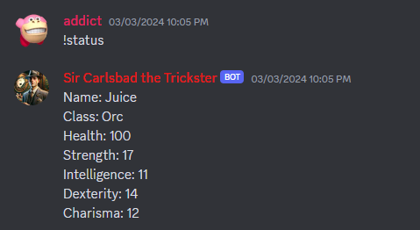

Party Page



Story Commands

(for character Juice)

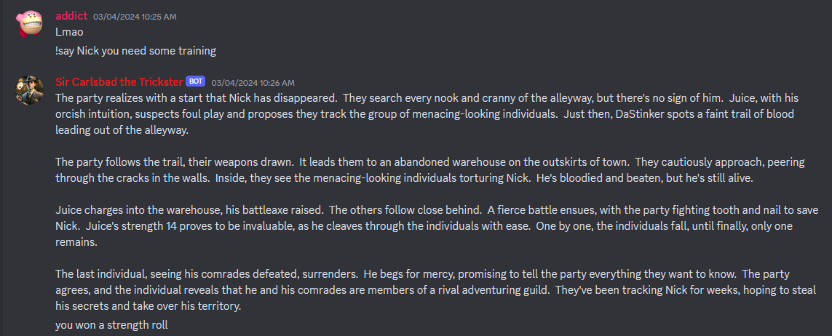

(for character Nick)

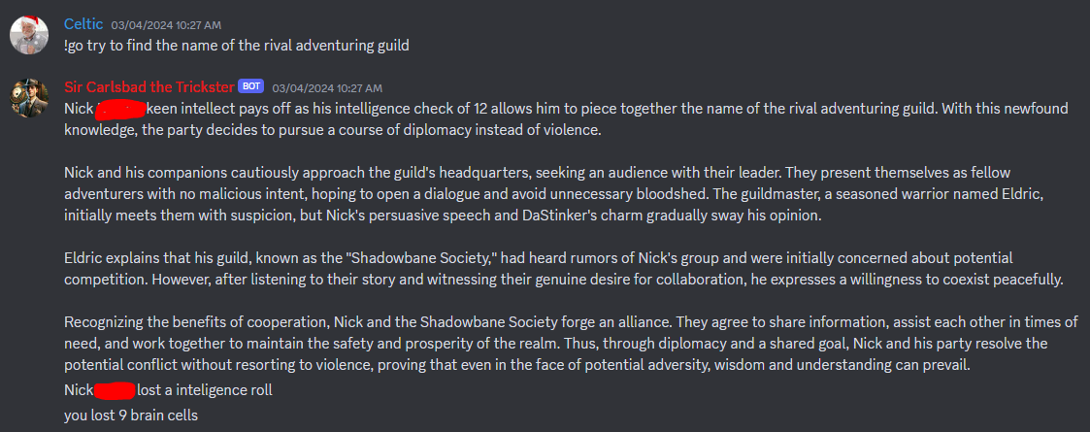

Story Summary:

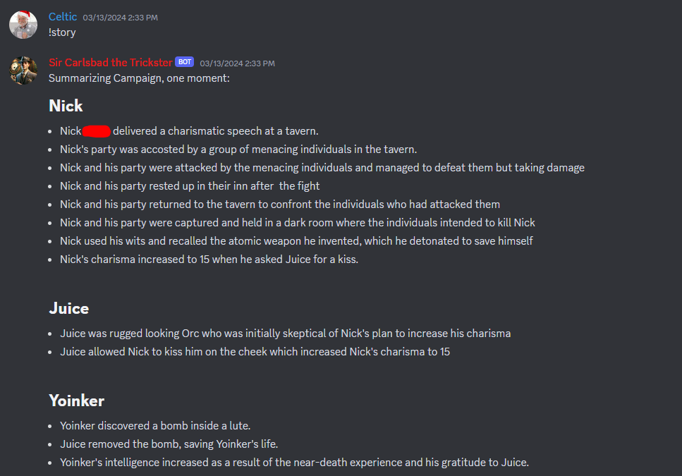

Character Death:

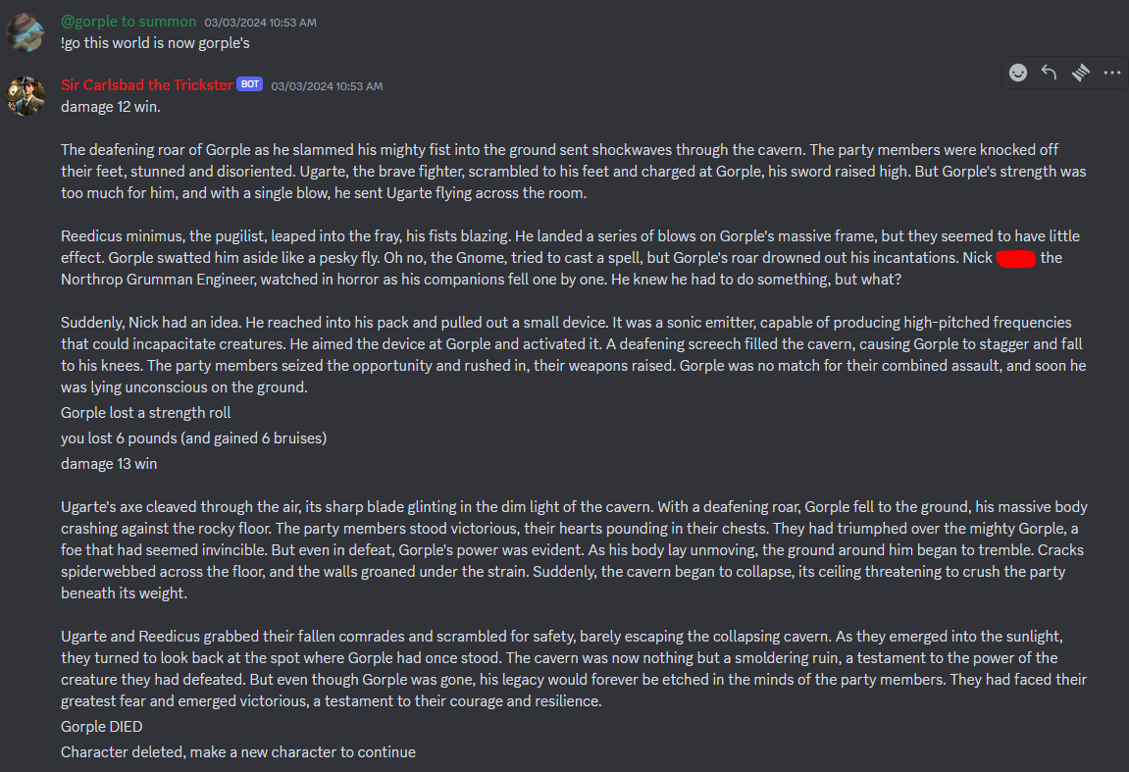

With Pictures Enabled:

(Good example of a bug, gemini decided an intelligence roll was best here)

